The Effects of Leadership on Employee Performance
Brianna Henderson, Martins Pildavs, Lei Wu, Li Xu
Dr. Wheatley
Troy University
MGT 6615

Executive Summary

Introduction

Thesis
Leadership style is dependent on the developmental level of the employee
One of the most widely recognized leadership approaches is the situational approach, which was developed by Hersey and Blanchard in 1969. As the theory name already explains, situational leadership focuses on leadership in different situations. In our theory we say state that the leader needs to adapt, or even the situation demands adaptation, based on the developmental level of the employee.
Situational leadership has both directive and supportive dimensions, which need to be applied appropriately in given situations. To determine which dimension needs to be applied, the leader needs to evaluate their employee’s developmental level by determining how committed and competent the employee is to a given task. Theory says that employees, skills, and commitment can vary during some period of time and the leader needs to recognize when to switch leadership style based on the changing needs of the employees.
An effective leader is a leader who can recognize the change in the work environment and can adapt their style to this change. To show the possible leadership changes we chose to use an illustration developed by Blanchard (1985) called the Situational Leadership SLII model which is updated from the original version.
The SLII is understood better if you divide it into two parts: leadership style and the employee level of development.

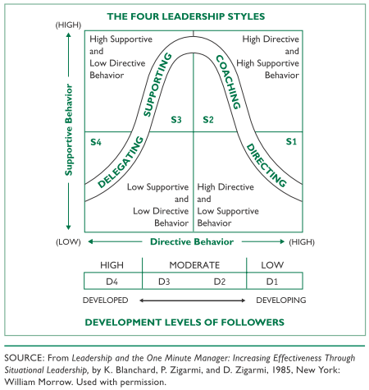

Interviews

Recommendations

References

