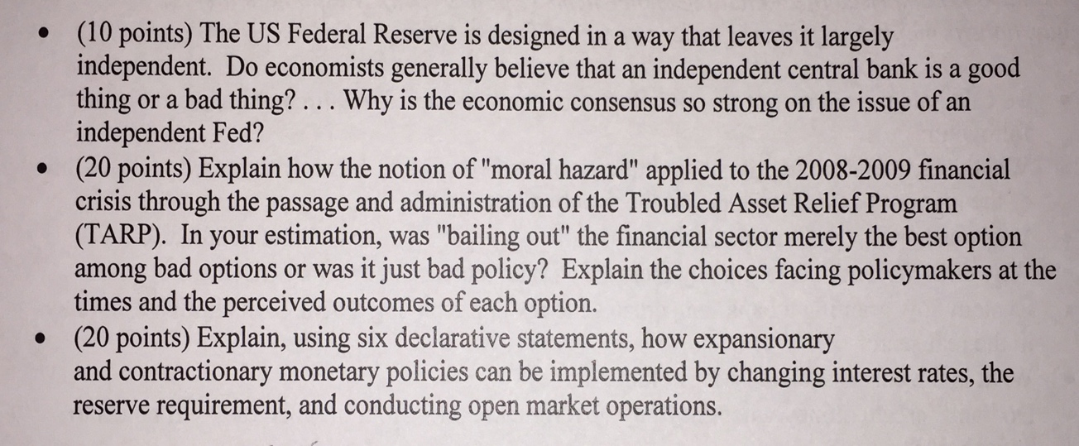
You need to write three responses for three prompts. Write around 150-200 words for the first prompt, 250-300 words for the second prompt, 250-300 words for the third prompt. Please be thoughtful and concise.

