For this assignment, refer to the scenario located in “Problems – Series A” section 10-19A of Ch. 10, “Planning for Capital Investments” of Fundamental Managerial Accounting Concepts. This scenario puts you at task as a Senior Accountant for Donovan Enterprises to identify the preferred method and best investment opportunity for the company.
Read the scenario in the textbook and complete the activity below.
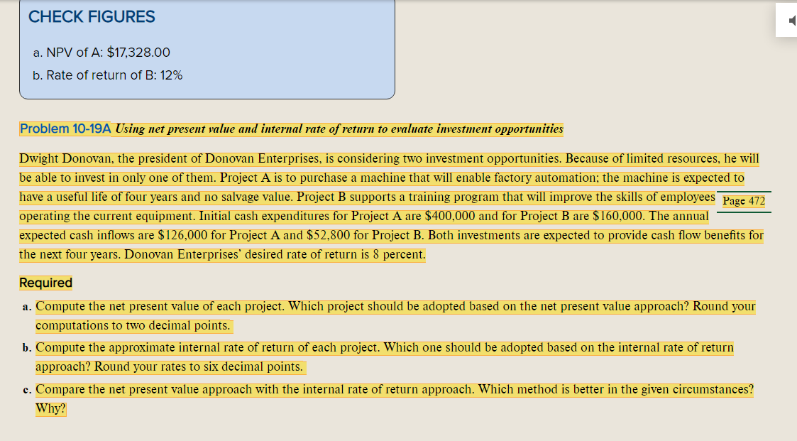

Use Excel®—showing all work and formulas—to compute the following:
- Compute the net present value of each project. Round your computations to 2 decimal points.
- Compute the approximate internal rate of return for each project. Round your rates to 6 decimal points

Create a PowerPoint® presentation showing the comparison of the net present value approach with the internal rate of return approach calculated above. Complete the following in your presentation:
- Analyze the results of the net present value calculations and the significance of these results, supported with examples.
- Determine which project should be adopted based on the net present value approach and provide rationale for your decision.
- Analyze the results of the internal rate of return calculation and the significance of these results, supported with examples.
- Determine which project should be adopted based on the internal rate of return approach and provide rationale for your decision.
- Determine the preferred method in the given circumstances and provide reasoning and details to support the method selected.
- Synthesize results of analyses and computations to determine the best investment opportunity to recommend to the president of Donovan Enterprises.

Cite references to support your assignment. Submit the Excel spreadsheet along with the presentation.

